2ND SEMESTER LAB REPORT
TITLE : ANALYSIS OF SERIES AND
PARALLEL CIRCUITS



Faiq Ali (249520)

Muhammad Zeeshan (243346)

Muhammad Waqas (240756)

BACHELOR OF COMPUTER ENGINEERING (Fall-2025)

Submitted To:
Engr. Shanzay amil
Lab Engineer

DEPARTMENT OF ELECTRICAL AND COMPUTER ENGINEERING FACULTY OF ENGINEERING AIR UNIVERSITY,ISLAMABAD

 | AIR UNIVERSITY
 | DEPARTMENT OF ELECTRICAL AND COMPUTER ENGINEERING
 | EXPERIMENT NO 4

Lab Title: VERIFCATION OF OHM’S LAW

Objective: 1. ANALYSIS OF SERIES AND parallel combinations of resistors
PARALLEL C IRCUITS

2. To measure the value of the resistor by Digital Multi-Meter (DMM).
Student Name:

Muhammad Waqas
-

-Muhammad Zeesha -Faiq Ali

LAB ASSESSMENT:
Attributes | Excellent  (5) | Good  (4) | Average  (3) | Satisfactory  (2) | Unsatisfactory  (1)
Ability to Conduct Experiment
Ability to assimilate the results
Effective use of lab equipment and follows the lab safety rules

Total Marks: Obtained Marks:

LAB REPORT ASSESSMENT:
Attributes | Excellent  (5) | Good  (4) | Average  (3) | Satisfactory  (2) | Unsatisfactory  (1)
Data presentation
Experimental results
Conclusion
Total Marks: Obtained Marks:
Date: 10/March/2025 Signature:

LABORATORY
EXPERIMENT
NO. 4
ANALYSIS OF SERIES AND
PARALLEL C IRCUITS

OBJECTIVE:
1. To verify total resistance RT in a circuit in which the resistors R1, R2, R3 etc are connected in series and parallel.
2. To develop a formula based on experimental results that gives the resistance RT of resistors connected in series and parallel.
3. To verify experimentally the branch resistances and the total Resistance of series and
parallel circuits.

Ohm’s Law:
Ohm’s Law is the basis of many electrical circuit calculations and is one of the most important
theories you will learn: V=IR.
Measuring Current in a Series Circuit Using a Digital Multimeter (DMM)
To measure the current in a series circuit with a digital multimeter (DMM), follow these steps:
- Turn Off Power – Ensure the circuit is powered off before making connections.
- Set the DMM – Turn the dial to the current (A or mA) setting.
- Break the Circuit – Since current flows in a single path in series, disconnect a wire at any point in the circuit.

========(Task 1)=========

Lab Task:
1. Solve for the following series circuits using ohm-meter:
a) Given the nominal values and tolerances in the table given below,determine and record the corresponding color code bands.
Resistors (Ω) | R1  (Ω) | R2  (Ω) | R3  (Ω) | R4  (Ω) | R5  (Ω) | R6  (Ω)
Band colors | Red-Red  Red-Gold | Orange-orange-red-gold | Yellow-violet-red | Yellow-green-blue | Brown-red-red-  gold | Brown-black-red-  gold
Rated value Ω | 2200 | 3300 | 470 | 4700 | 1200 | 1000
Measured  values Ω | 2169 | 3296 | 458 | 4560 | 1213 | 0.991

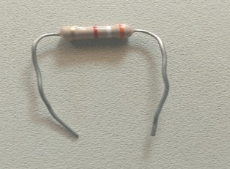 | 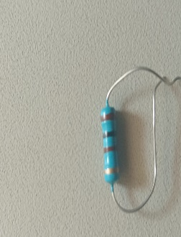 | 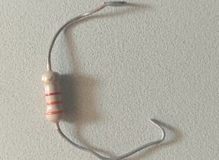
2200 Ω | 470 Ω | 3300 Ω

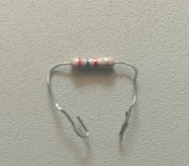 | 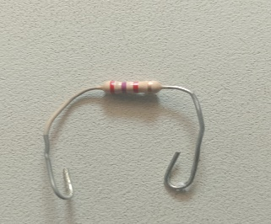 | 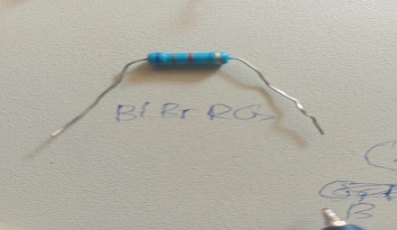
4700 Ω | 1200 Ω | 1000 Ω

> >>>>>>(a)<<<<<<<<
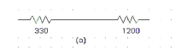
1000
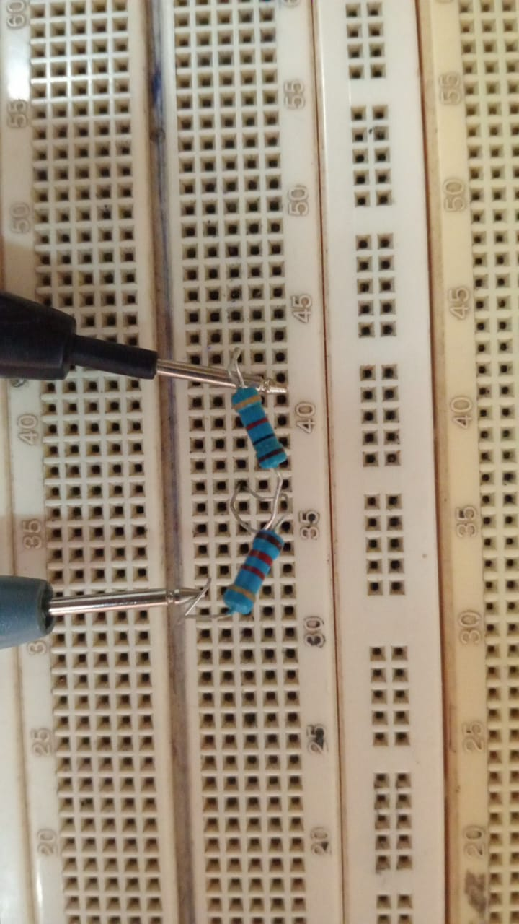 | 330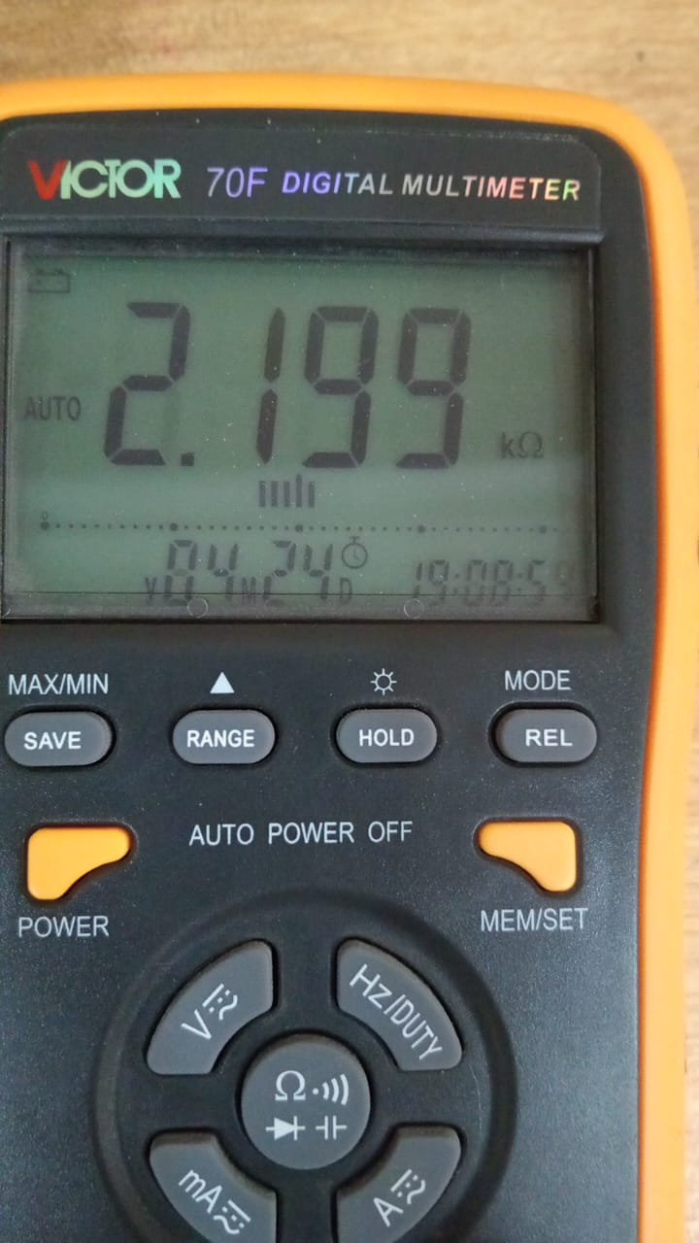
This is a mother-board a resitor of 1000 and 1200 ohm | Multimeter: Show equivalence resitence for resistors connected in series
Rated value: 2.2k Ω | Measured Value:2.199k Ω

> >>>>>>(b)<<<<<<<<

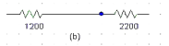

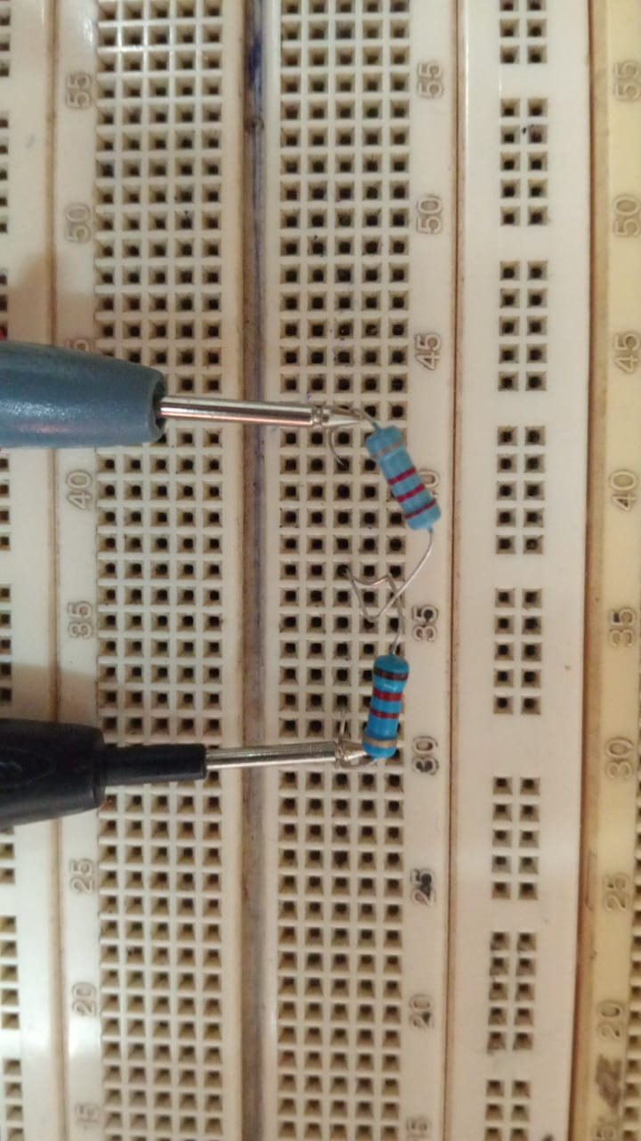 | 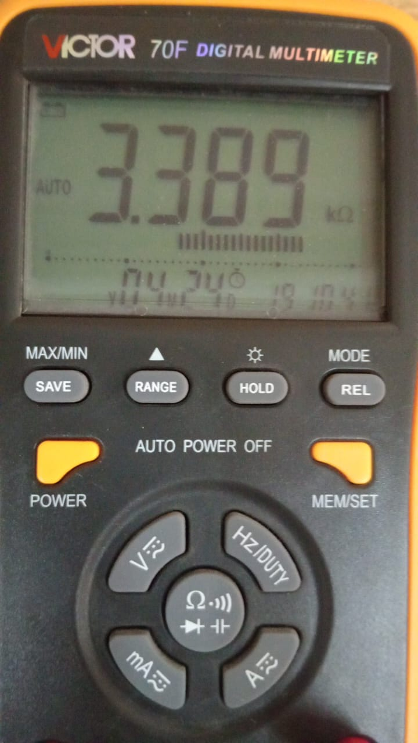
Motherboard  R1+R2=1200+2200=3300 | Mulimeter: Show equivalence resitence for resistors connected in series
Rated value: 3.3k Ω | Measured Value:3.389k Ω

\

> >>>>>>(c)<<<<<<<<

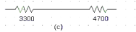

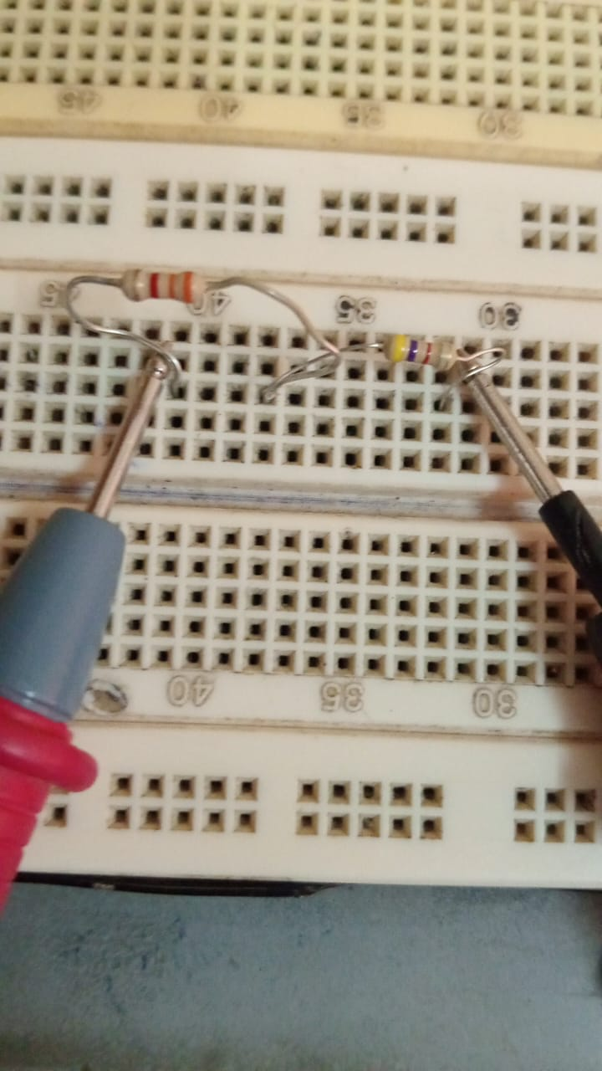 | 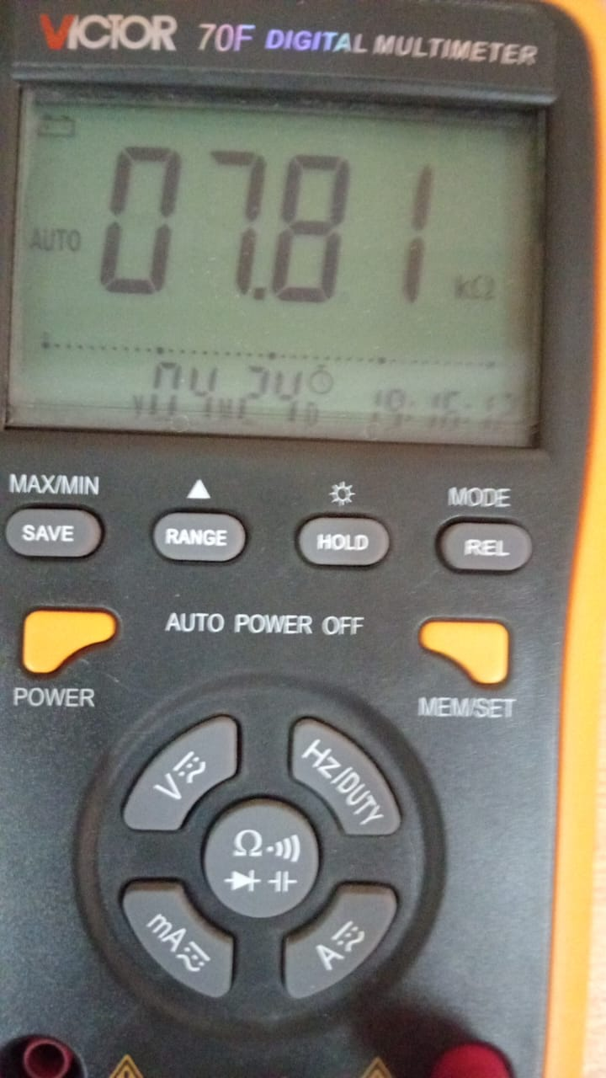
Motherboard  R1+R2=3300+4700=8000 | Mulimeter: Show equivalence resitence for resistors connected in series
Rated value: 8k Ω | Measured Value:7.81k Ω

> >>>>>>(d)<<<<<<<<

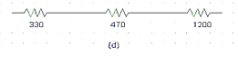

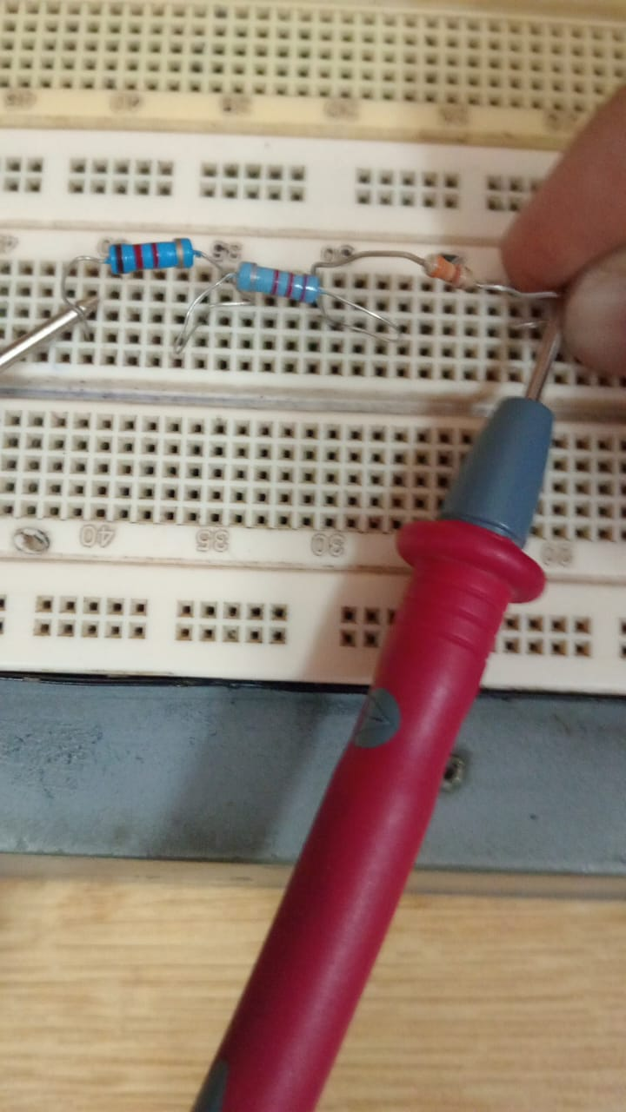 | 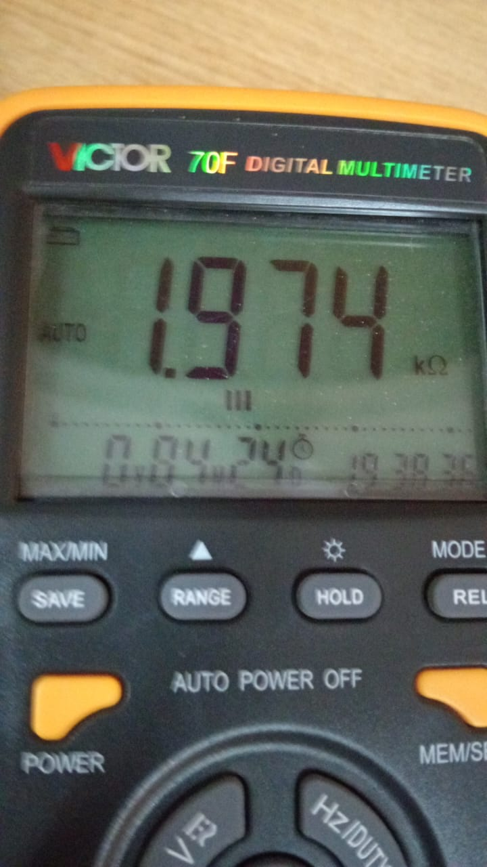
Motherboard  R1+R2+R3=330+470+1200=2000 | Mulimeter: Show equivalence resitence for resistors connected in series
Rated value: 2k Ω | Measured Value:1.974k Ω

> >>>>>>(e)<<<<<<<<

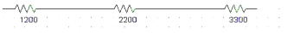

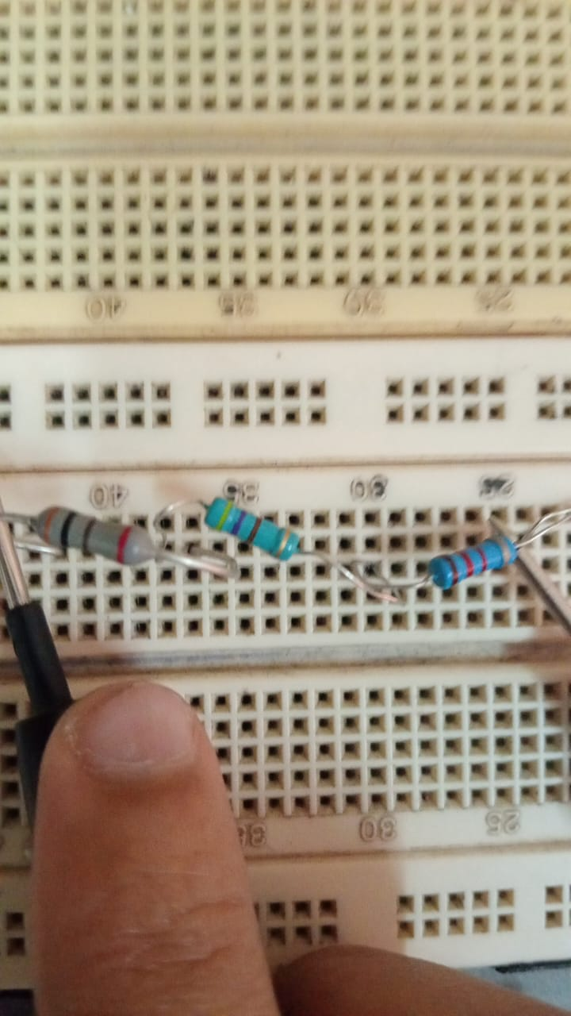 | 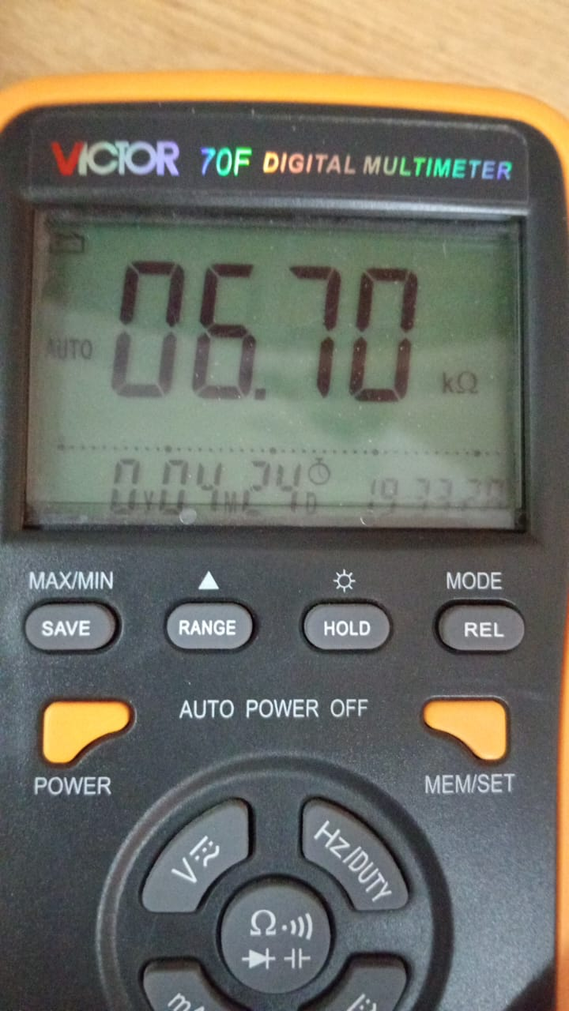
Motherboard  R1+R2+R3=1200+2200+3300=6700 | Mulimeter: Show equivalence resitence for resistors connected in series
Rated value: 6.7k Ω | Measured Value:6.70k Ω

>>>>>>>(f)<<<<<<<<

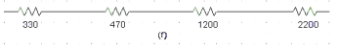

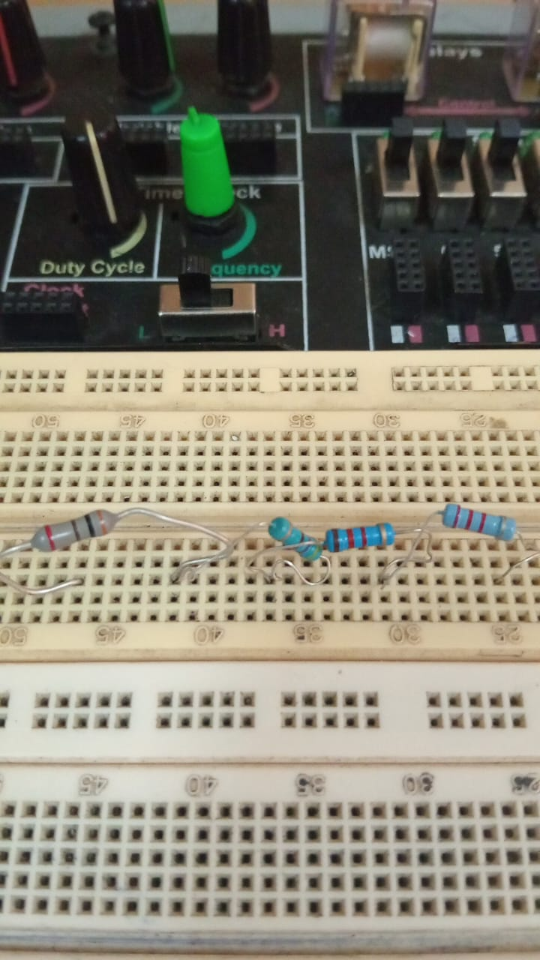 | 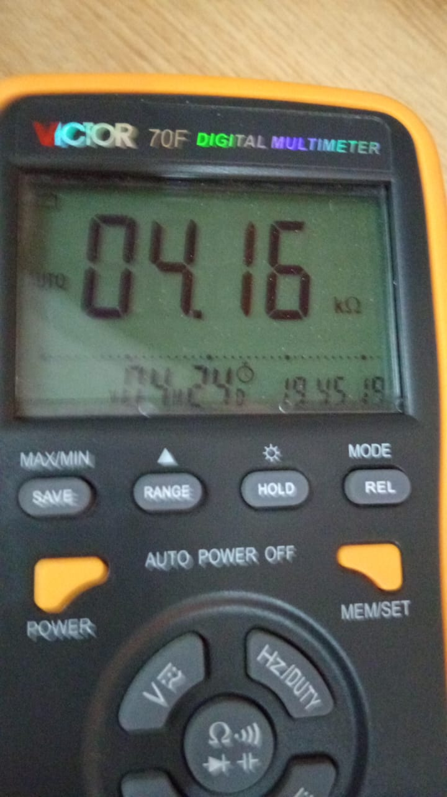
Motherboard  R1+R2+R3+R4=330+470+1200+2200  =4200 | Mulimeter: Show equivalence resitence for resistors connected in series
Rated value: 4.2k Ω | Measured Value:4.16k Ω

>>>>>>>(g)<<<<<<<<
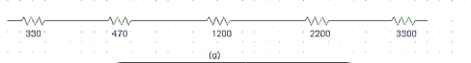

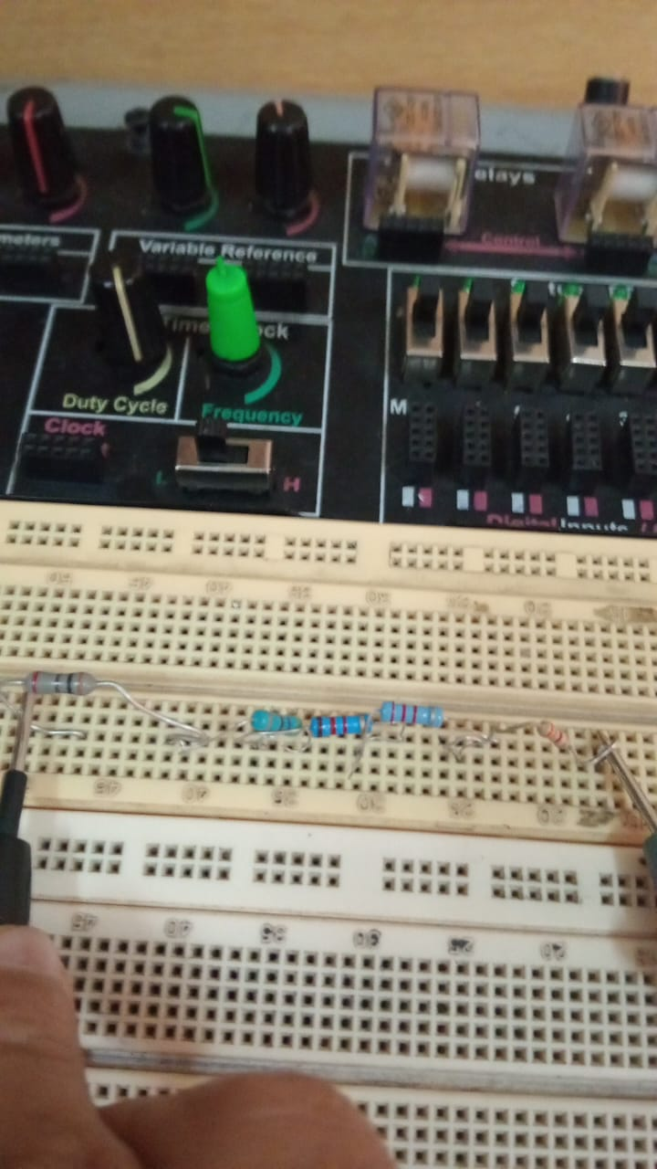 | 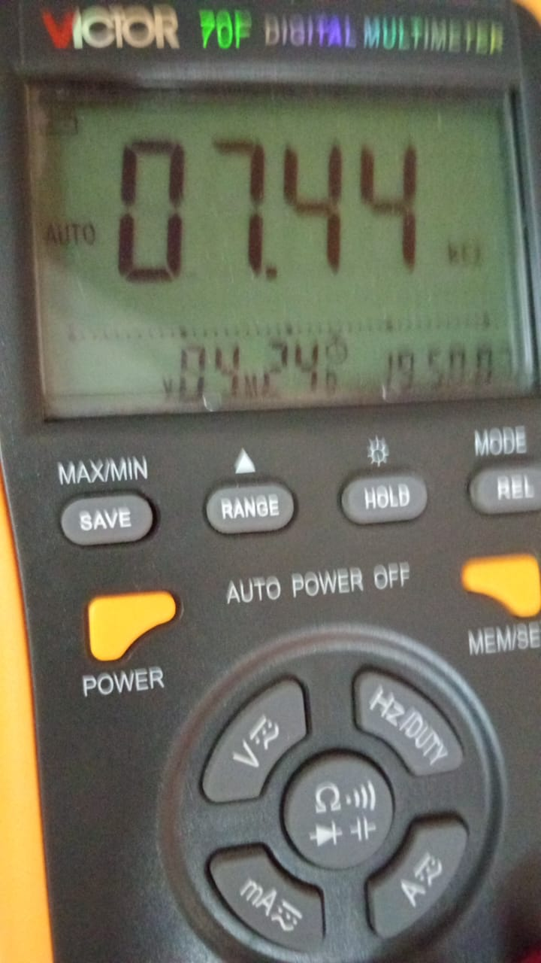
Motherboard  R1+R2+R3+R4+R5=  330+470+1200+2200+3300  =7600k | Mulimeter:Show equivalence resitence for resistors connected in series
Rated value: 7.6k Ω | Measured Value:7.44k Ω

Table of all combinations::

Combinations | R1 | R2 |  | R3 |  | R4 |  | R5 |  | R |  | Measured Value (Ω) |  | Calculated Value (Ω) |  | Formula for RT
A | 1000 |  | * |  | 1200 |  | * |  | * |  | * |  | 2.199KΩ |  | 2.2KΩ | R1+R2...Rn
B | 1200 |  | * |  | 2200 |  | * |  | * |  | * |  | 3.389KΩ |  | 3.3KΩ | R1+R2...Rn
C | * |  | * |  | 4700 |  | 3300 |  | * |  | * |  | 8KΩ |  | 7.81KΩ | R1+R2...Rn
D | 330 |  | * |  | 470 |  | * |  | 1200 |  | * |  | 2KΩ |  | 1.970KΩ | R1+R2...Rn
E | 3300 |  | * |  | 2200 |  | * |  | 1200 |  | * |  | 6.7KΩ |  | 6.70KΩ | R1+R2...Rn
F | 330 |  | 470 |  | 1200 |  | * |  | 2200 |  | * |  | 4.2KΩ |  | 4.16KΩ | R1+R2...Rn
G | 330 |  | 470 |  | 1200 |  | 3300 |  | 2200 |  | * |  | 7.6KΩ |  | 7.44KΩ | R1+R2...Rn

========(Task 2)=========
 | 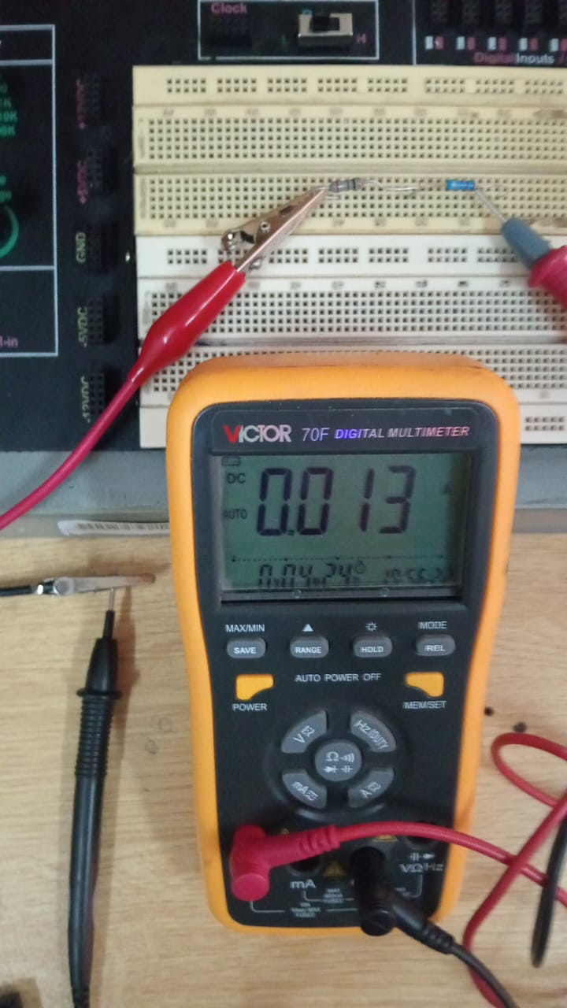
Motherborad with rsesitors in seriers | Int this image multimeter is connected ion serieries with resistrors to measure current

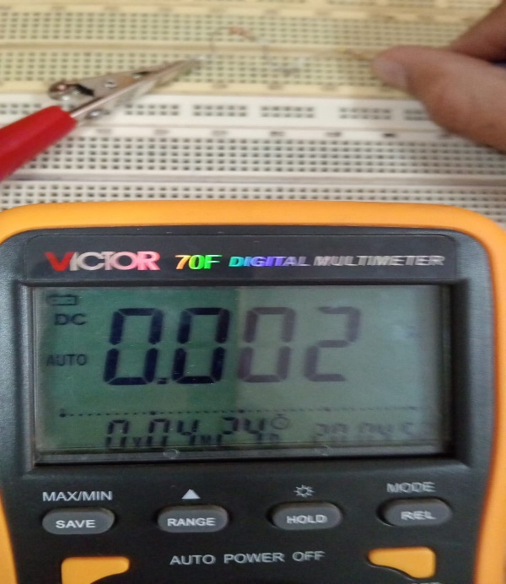
Int this image multimeter is connected ion serieries with resistrors to measure current

Table of all combinations:

Combinations | Applied Voltage (V) | Measured Current (I) | Ohm’s Law (R = V/I) (Ω) | Measured Resistance (Ω) | Calculated Resistance (Ω)
A | 10V | 4.54mA | 2.20KΩ | 2.199KΩ | 2.2KΩ
B | 10V | 3mA | 3.33KΩ | 3.389KΩ | 3.3KΩ
C | 10V | 1.3mA | 8.0KΩ | 8KΩ | 7.8KΩ
D | 10V | 5mA | 2.0Ω | 2KΩ | 1.970KΩ
E | 10V | 1.49mA | 6.71KΩ | 6.7KΩ | 6.7KΩ
F | 10V | 2.38mA | 4.20KΩ | 4.2KΩ | 4.16KΩ
G | 10V | 1.31mA | 7.63KΩ | 7.6KΩ | 7.44KΩ

Conclusion:
In a series circuit, the total resistance (RTR_TRT​) is the sum of all individual resistances, causing the overall resistance to increase and the current to decrease according to Ohm’s Law (V=IRV = IRV=IR). To measure the current in a series circuit using a digital multimeter (DMM), the circuit must be powered off first. The DMM is then set to the appropriate current (A or mA) setting, and its probes are connected in series by breaking the circuit at any point. Once the circuit is powered on, the DMM displays the current, which remains the same throughout all resistors in the series combination
Connect the Multimeter in Series –
- Plug the red probe into the A or mA port (depending on the expected current).
- Plug the black probe into the COM port.
- Place the probes at the two ends of the break in the circuit.
Turn On Power – Switch on the circuit, and the DMM will display the current.
Observe the Reading – In a series circuit, the current remains the same throughout all resistor

